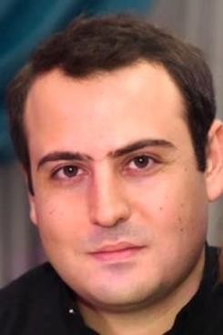

109 home, Noy district, Yerevan, Armenia
SARGIS AGHASYAN
 (+374) 94811189
 s.aghasyan@yahoo.com

EDUCATION | WORK EXPERIENCE  - ARMECONOMBANK OJSC (2016-Present)  Position: Head of Litigation Division  - BTA BANK CJSC (2016)  Position: Head of Legal Service  - ARMECONOMBANK OJSC (2013-2016)  Position: Senior Legal Advisor  - CARD FUNDATION (2015-Present)  Position: Member of Board of Trusties  - CARD AGROSERVICE CJSC (2015-Present)  Position: Board Member  - CARD AGROCREDIT UCO CJSC (2013-Present)  Position: Board Member  - LEGELATA LLC (2013)  Position: Lawyer/ Attorney  - INECOBANK CJSC (2012-2013)  Position: Legal Advisor  - CHAMBER OF ADVOCATES OF RA (2012-Present)  Advocate  - ARMENIAN YOUNG LAWYERS ASSOCATION NGO (AYLA)  Advocacy and Assistance Centers (AACs) program  Position: Senior Lawyer/Coordinator of Aragatsotn AAC 2011-2012 Position: Legal Advisor of Yerevan AAC 2011  - ARKO-ALKOND LLC (2010)  Position: Lawyer
Yerevan State University 2005-2009
Faculty of Law
Specialization: European Law

Yerevan State University 2009-2011
Faculty of Law
Specialization: International Law
LANGUAGES
Armenian 
English 
Russian 
French 
IT SKILLS
MS Office
Internet
OTHER
The Armenian Genocide Museum-Institute Foundation
Lawyer

Public Network ULE
Expert/Lawyer of Counterpart
International’s grant program

Yerevan State University/
Department of the Postgraduate
Additional Education
Lecturer

